Notice of Voting System Exhibition, Diagrams and Voting Instructions

Pursuant to 13-17-203, not more than 10 or less than 2 days before an election at which a voting system will be used, the election administrator shall broadcast on radio or television, as provided in 2-3-105 through 2-3-107, or publish in a newspaper of general circulation in the county:
a diagram showing the voting system to be used by voters and a sample of the ballot layout (in newspaper only); a statement of the locations where voting systems to be used by voters are on public exhibition; and instructions on how to vote. The election administrator shall select the method of notification that the election administrator believes is best suited to reach the largest number of potential electors.

Notice to be published in newspaper of general circulation in county (or broadcast on radio or television as applicable)

Notice of Voting System Exhibition and Ballot Layout:

Please note that the county’s voting systems are on public exhibition at __________________________________________________from _____________, 20__ through ____________, 20__. Please see diagrams of the voting system(s) and ballot arrangement and instructions on voting below.

SAMPLE BALLOT LAYOUT – Ballot marked by Voter or Automark voting system

Sample County | State of Montana | Election Date
INSTRUCTIONS TO VOTERS  1. TO VOTE, COMPLETELY FILL IN ( ) THE OVAL USING A BLUE OR BLACK PEN.  2. To write in a name, completely fill in the oval to the left of the line provided, and on the line provided print the name of the write-in candidate for whom you wish to vote.  3. DO NOT MAKE AN IDENTIFYING  MARK, CROSS OUT, ERASE, OR USE CORRECTION FLUID. If you make a mistake or change your mind, exchange your ballot for a new one.  VOTE IN ALL COLUMNS  (VOTE BOTH SIDES) | COUNTY  (Continued) | COUNTY  (Continued)
 | FOR SAMPLE OFFICE 1  (VOTE FOR ONE)  JOHN ADAMS  gEORGE WASHINGTON  ____________  FOR SAMPLE OFFICE 2  (VOTE FOR ONE)  wILLIAM h. hARRISON  Martin Van Buren  Andrew Jackson  jOHN tYLER  ____________ | FOR SAMPLE OFFICE 3  (VOTE FOR ONE)  jAMES bUCHANAN  ____________  aBRAHAM LINCOLN

Updated January 28, 2020

Instructions on How to Vote on an EXPRESSVOTE Voting System

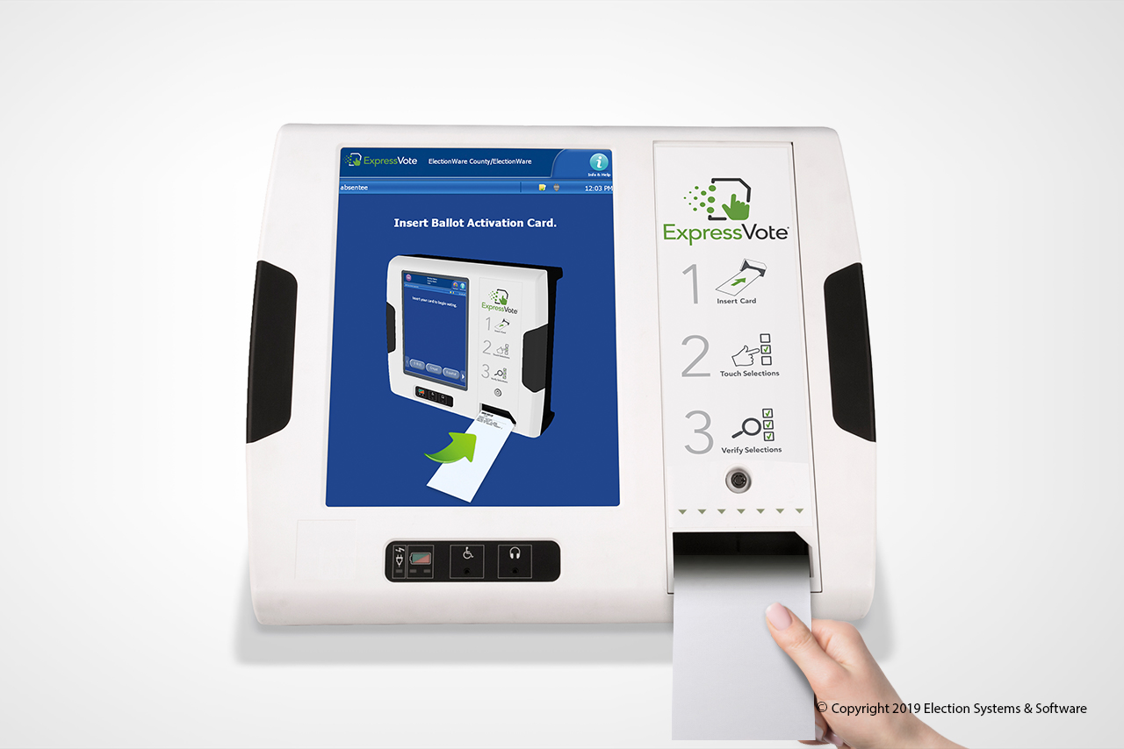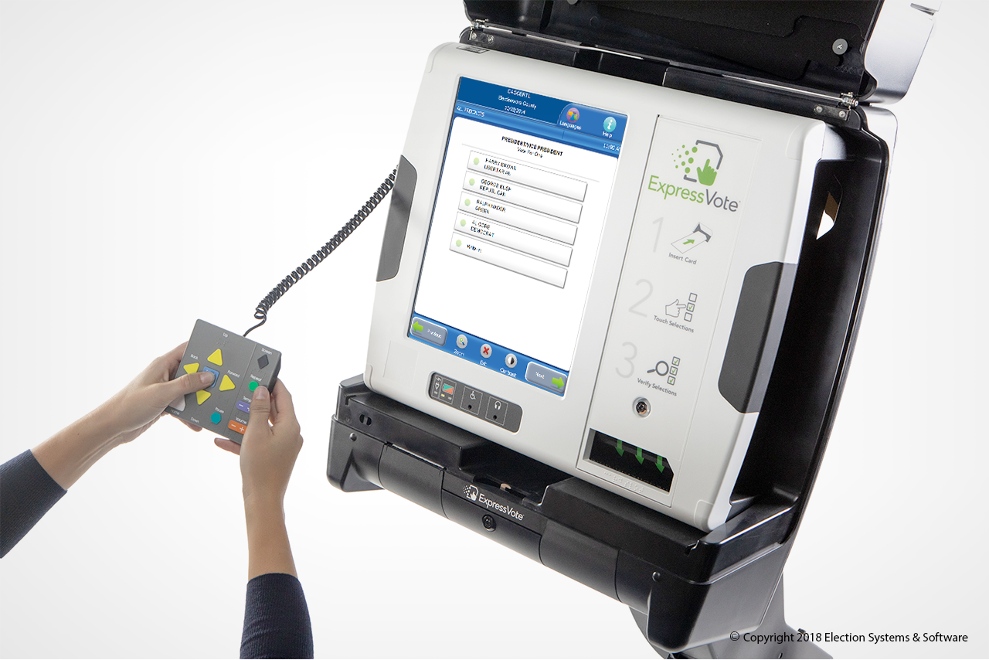
Touchscreen
Ballot Entry Slot
Touchscreen
Ballot Entry Slot

The ExpressVote is a ballot-marking system that is available for anyone to use during the upcoming election. Its main purpose is to allow voters with disabilities and other special needs to mark a ballot privately and independently.

- Inform the election official that you wish to vote using ExpressVote.
- You will be issued a ballot card.
- Insert the ballot card into the ballot feed tray on the front of the machine.
- The screen will display instructions and the ballot choices.
- The following helpful options are available:
  - Change contrast and font size for readability
  - Audio headphones
  - Braille keypad
  - Connection for Sip-n-Puff personal device
- Make your selections by using the touch-screen capability, or by using the keypad.
- After you have completed your selections, the ExpressVote will confirm your selections on the screen, and by audio if you
select the audio option.
- 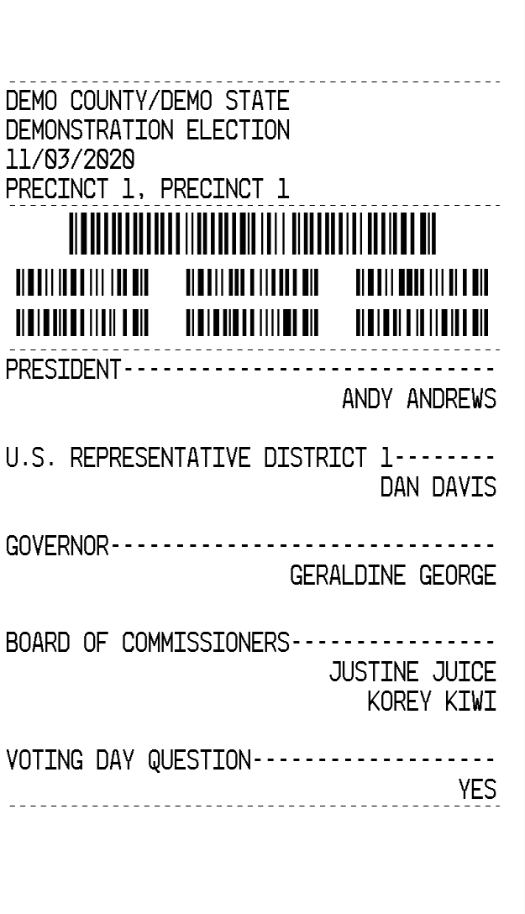After verifying your selections, the ExpressVote will mark and print out your ballot card.
Barcodes of election information and votes
Votes for candidates and measures are printed on the card.
Election Information
- Confirm your choices on the printed and marked ballot card.
- Return the marked ballot card to the election official.
- You can request help anytime during the process.

Instructions on How to Vote on an AutoMARK Voting System

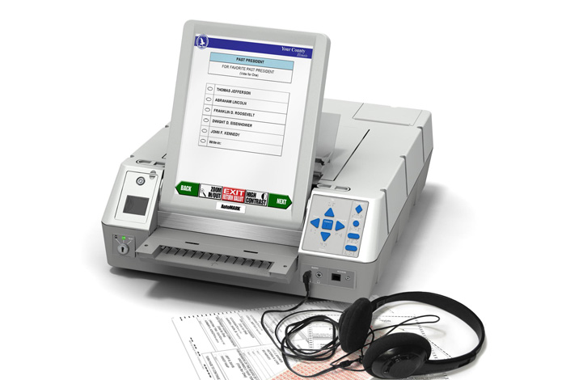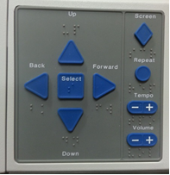wwwww
Ballot Entry Slot
Touchscreen
Volume
Audio Speed
Audio Repeat
Screen On/Off

The AutoMARK is a ballot-marking system that is available for use during the upcoming election. Its main purpose is to allow voters with disabilities and other special needs to mark a ballot privately and independently.

- Inform the election official that you wish to vote using the AutoMARK.
- You will be issued a regular ballot.
- Insert the ballot (with stub removed) into the ballot feed tray on the front of the machine.
- The screen will display instructions and the ballot choices.
- The following helpful options are available:
  - Change contrast and font size for readability
  - Audio headphones
  - Braille keypad
  - Connection for Sip-n-Puff personal device
- Make your selections by using the touch-screen capability, or by using the keypad
- After you have completed your selections, the AutoMARK will confirm your selections on the screen, and by audio if you
select the audio option.
- After verifying your selections, the AutoMARK will mark and print your ballot.
- Return the marked ballot to the election judge.
- You can request help anytime during the process.

Instructions on How to Vote on an M-100 Precinct Tabulator

The M100 is a precinct level tabulator that will be available to tabulate your ballot at your polling location. The M100 will notify you if you have overvoted or undervoted on any races on the ballot.

- To vote, fill in the oval completely.
- Vote both sides and all sheets.
- Use only black or blue ink to mark your ballot. An optical or digital tabulator will count your ballot. If you use any other type of marking instrument, it may not be detected by the tabulator.
- When marking your ballot you should NOT make an X or a check mark. You should NOT cross out, erase, or use correction fluid on the ballot and if you make an error, you should request a new ballot.
- READ INSTRUCTIONS CAREFULLY! If you mark more candidates than you are allowed to mark for that position, it is considered an overvote. You may request a new ballot if you overvote in any race. If you do not correct your ballot, that race will not count because of the overvote; however, the remainder of your ballot will be counted.
- After you mark the ballot, you will be directed to insert the ballot in the M-100 precinct tabulator, which will alert you to overvotes or undervote, if any, and after you verify your selections, the M-100 will tabulate your choices and deposit the ballot in the ballot box.

Control Buttons
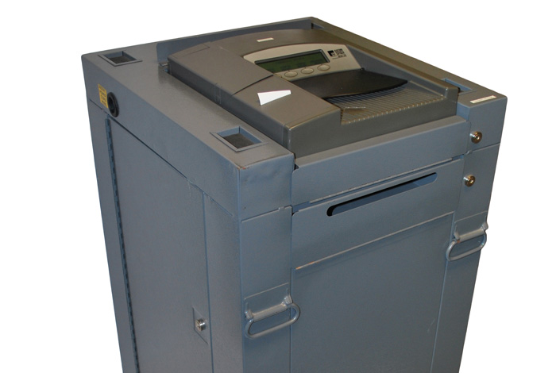
Emergency Ballot Bin
Ballot Box
LCD Screen
Ballot Entry Slot

INSTRUCTIONS ON HOW TO VOTE ON A DS-200 PRECINCT TABULATOR

The DS200 is a precinct level tabulator that will be available to tabulate your ballots at your polling location. The DS200 will notify you if you have overvoted or undervoted on any races on the ballot.

- To vote, fill in the oval completely.
- Vote both sides and all sheets.
- Use only black or blue ink to mark your ballot. An optical or digital tabulator will count your ballot. If you use any other type of marking instrument, it may not be detected by the tabulator.
- When marking your ballot you should NOT make an X or a check mark. You should NOT cross out, erase, or use correction fluid on the ballot and if you make an error, you should request a new ballot.
- READ INSTRUCTIONS CAREFULLY! If you mark more candidates than you are allowed to mark for that position, it is considered an overvote. You may request a new ballot if you overvote in any race. If you do not correct your ballot, that race will not count because of the overvote; however, the remainder of your ballot will be counted.
- After you mark the ballot, you will be directed to insert the ballot in the DS-200 precinct tabulator, which will alert you to overvotes or undervote, if any, and after you verify your selections, the DS-200 will tabulate your choices and deposit the ballot in the ballot box.

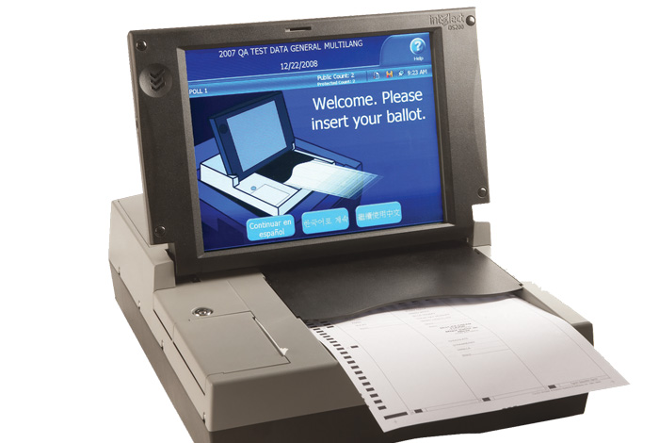
Ballot Entry Slot
Touchscreen

