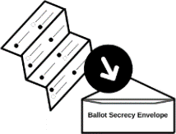
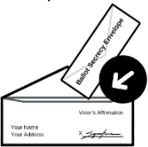
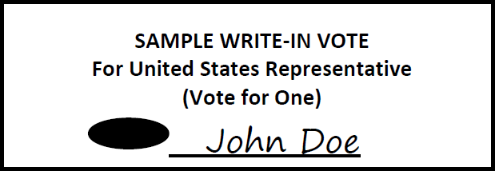
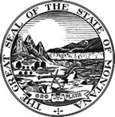
Due to the COVID-19 pandemic, polling places WILL NOT be open in County on Election Day

MAIL BALLOT VOTING INSTRUCTIONS – GENERAL ELECTION BALLOT
Read and follow all directions - Failure to follow directions may invalidate part or all of your ballot
Ballots must be received by the election office by 8 p.m. on November 3, 2020
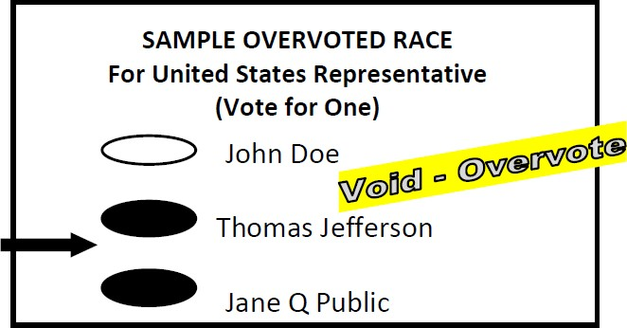
NO POSTAGE REQUIRED IF RETURNING YOUR BALLOT BY MAIL

Vote your ballot with a blue or black pen.  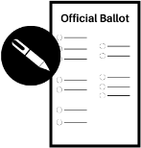  Seal your voted ballot in ballot secrecy Envelope. | VOTE YOUR BALLOT  - Completely fill in the oval for each race using only black or blue ink pen.  - Vote all columns, both sides, and all pages of the ballot. Skipping a race will not invalidate your ballot.  - Do not make an X, √, or another mark.  - Do not cross out, erase, or use correction fluid.  - Do not make any identifying marks on your ballot.  - Do not mark more choices than allowed for each race (overvote). Overvoted races are NOT counted.  - To write in a candidate’s name, completely fill in  the oval next to the line and print the name
 | in the blank space.
 | - If you make a mistake or spoil your ballot, request
 | a replacement from your county election office.
Sign the Voter’s affirmation  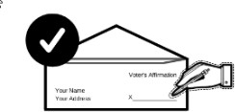  Seal your ballot secrecy envelope inside the return envelope. | PREPARE BALLOT TO SEND  - Place voted ballot in the SECRECY ENVELOPE and seal the envelope.  - SIGN the voter affirmation on the Return Signature Envelope.  - Do not sign for another person.  - Failure to sign may invalidate your ballot.  - If your signature does not match your signatures on file, the ballot may be rejected.  - Place the Secrecy Envelope containing your VOTED ballot into the Return Signature Envelope and seal the envelope.  RETURN BALLOT  Mail your ballot: The Postal Service recommends you mail your ballot at least one week before the election; or you may drop your ballot off at your county election office:
 | COUNTY ELECTION OFFICE
 | Address
 | City/Zip
Return your ballot by mail or in person. Your ballot must be received by 8pm on Election Day, 11/03/2020 | Ballots must be RECEIVED at the election office by 8 p.m. on Election Day, November 3, 2020. A postmark is not accepted. If you mail your ballot make sure there is enough time for it to reach your election office.  TRACK YOUR BALLOT  View the status of your absentee ballot and the Voter Information Pamphlet on the “My Voter Page” at: https://app.mt.gov/voterinfo/
 | MILITARY/OVERSEAS VOTERS: Active-duty absent military or overseas citizens can register and vote electronically. See sosmt.gov or Montana Electronic Absentee System (MT EAS) at www.vote4montana.us.
No postage is necessary to return your ballot by mail. Return postage is pre-paid. | ASSISTANCE FOR VOTERS WITH DISABILITIES: There are options for voters with disabilities including equipment for individuals with visual and mobility impairments. Contact your county election office for more information.  IF YOU HAVE QUESTIONS CONTACT YOUR COUNTY ELECTION OFFICE:  Phone: Fax:
 | Email:

